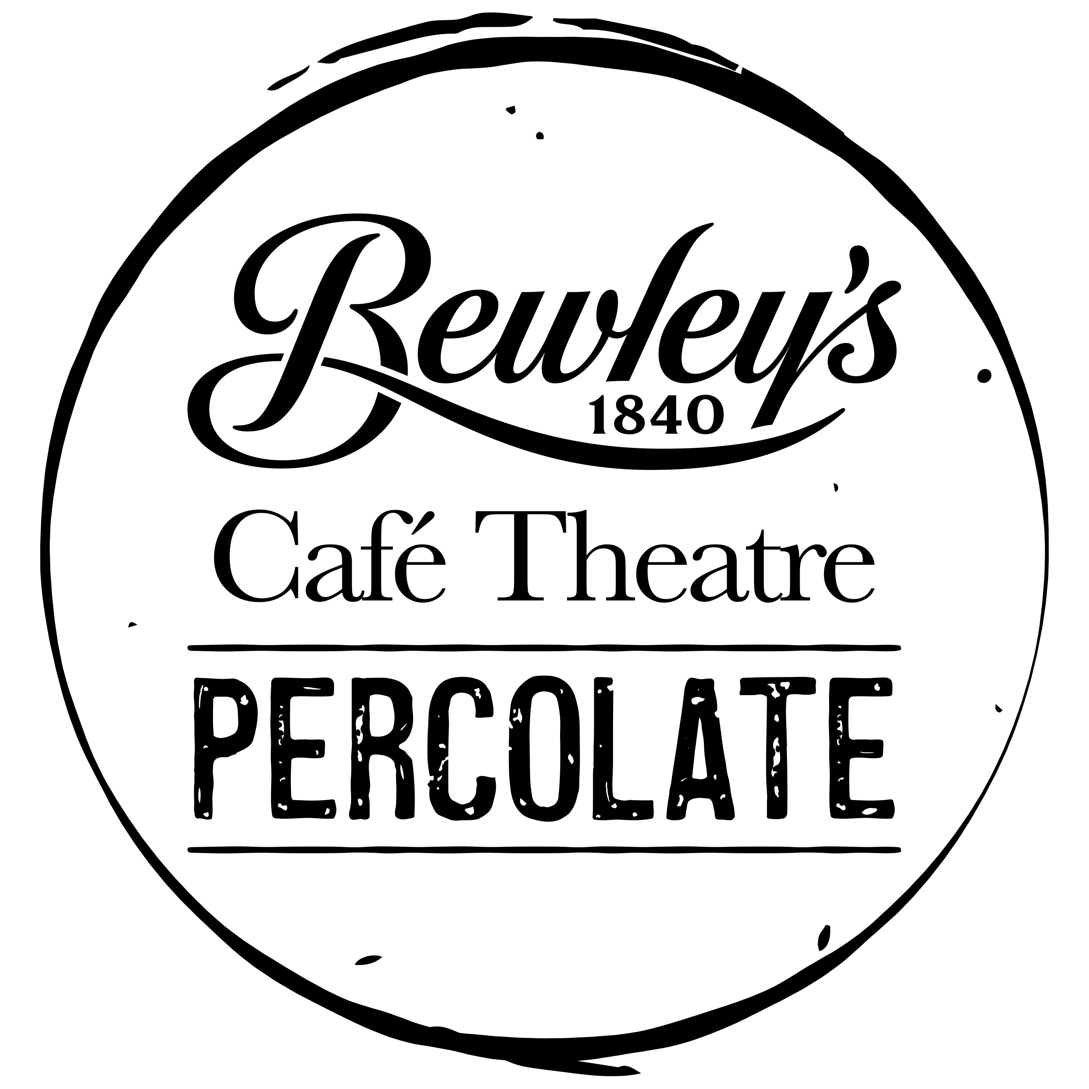

BEWLEY’S CAFÉ THEATRE
OPEN CALL TO PLAYWRIGHTS

Introduction
Bewley’s Café Theatre is delighted to announce that Percolate – a development programme for playwrights at all stages in their career – is again seeking applications from new writers.

In January 2021, Bewley’s Café Theatre began its inaugural development programme for playwrights with an ambition to raise the level of discussion and engagement with new dramatic writing in Ireland and to be a resource for the wider Irish theatre community.

Having launched, supported, nurtured and encouraged new plays and playwrights over the last two decades, we are proud to again be offering this kind of sustained support to writers.

We are now forming an Artistic Advisory Panel – six theatre artists with a variety of experience and expertise – who will actively collaborate with playwrights, offering engagement, feedback and a continuing dialogue on their work.

Bewley’s Café Theatre is looking to select a new group of 6 dramatic writers.

What we offer:

- Regular individual meetings involving direct feedback on writer’s work
- A series of playwriting workshops/masterclasses pitched to ability and experience (separate to the discussion of individual writer’s work)
- Engagement from the entire advisory panel and a continuing relationship with Bewley’s Café Theatre
- Creative Production Support to encourage a path to production
- Financial stipend of €1000 for initial 4 months

Work does not have to be suitable for Bewley’s Café Theatre. Full length plays and large casts are as welcome as work that fits our lunchtime slot. The Workshops/Masterclasses will focus on the tools and frameworks of the dramatist’s craft. As these workshops can be advanced in nature, graduates from other new writing support programmes are welcome, as well as playwrights with established track records.

While production is the aim it cannot be guaranteed; Bewley’s Café Theatre will provide showcase opportunities, connections to the wider industry, rehearsed readings and a continuing dialogue with the playwright. This continuing relationship guarantees a minimum of two years of engagement with Bewley’s Café Theatre and the Artistic Advisory Panel.

Bewley’s Café Theatre is committed to equality and diversity. Writers with disability and from Black, Asian and minority ethnic backgrounds are encouraged to apply. We value the positive impact that comes from hearing diverse voices on our stages.

Conditions of selection

Writers are invited to submit an application, which is attached below with criteria.

Applications are open to the residents of the Republic of Ireland and Northern Ireland.

Applications will be assessed by an expert panel according to the criteria published below and applications will be shared with all panellists.

The stipend will be drawn down in two tranches, the first on formal acceptance of joining the Bewley’s Café Theatre Percolate programme, the second midway through the workshop/masterclass series.

Key dates
02 November 2023 Announcement of Open Call
12 December 2023 Closing date for applications
01 February 2024 Formal offers announced

Criteria
Applications will be assessed according to the following criteria:
- Eligibility of Application – the application form is completed in appropriate detail and is submitted on time.
- Quality and Nature of Proposal – the excellence and originality of the piece of work being proposed in terms of theme or idea and/or in terms of formal approach.
- Sample of Dramatic Writing (maximum 10 pages) - the quality of the scene/dialogue.
- Track Record of Artist Involved – the achievements to date of the individual making the proposal. In the case of “early-career” applicants, the Biographical Note, allowing for an artistic statement, will also be taken into account.

BEWLEY’S CAFÉ THEATRE
OPEN CALL TO PLAYWRIGHTS

APPLICATION FORM

Details of Primary Contact
Name
Address
Email
Phone
Website / Facebook / Twitter

Application Essentials
- Completed application form
- Sample Writing
In word or .pdf form, please send as separate attachment, clearly labelled. Hard copies of supporting material are not accepted.

Checklist
I have completed all sections of the form below and not exceeded the word count
I have attached PDF or Word versions of supporting material (maximum 10 pages)
I have provided online links to documentation of my work, if applicable

Please read the entire application form before completing any section so as to avoid repetition / overlap

1: Biographical Note of Playwright
Give a brief account of your work to date. You may choose to add a summary of what you hope to achieve as a writer – bearing in mind that we may not be familiar with you or your work (100 words max.)

2. Your proposal in summary (300 words max.)
Describe the play you plan to write / submit for consideration to the Artistic Advisory Panel during the Percolate programme
(does not have to be suitable for Bewley’s Café Theatre Lunchtime slot)

3. Online links to work
List online links to documentation of your work (videos and images) and any supporting material (reviews, articles, etc.)

Applications are open to anyone resident in both the Republic and Northern Ireland.

How to Submit and Key Dates
Please e-mail your completed application form, along with the sample of your writing, to David Horan:
bewleyscafetheatre@gmail.com by 5pm on Tuesday 12 December 2023

Terms: No late applications will be accepted. All decisions are final, and no correspondence will be entered into. We regret that we cannot provide feedback on individual applications.

